Chennai House Price Prediction Report

**Exploratory Data Analysis**

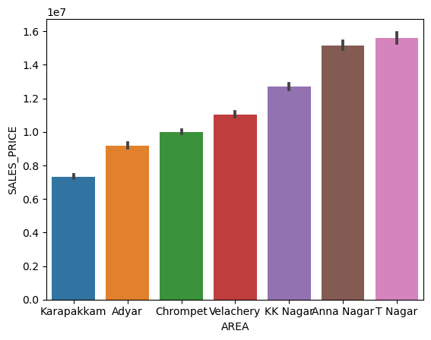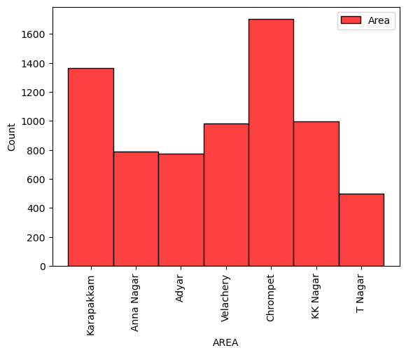

**Its a case of a linear relationship and will use Label Encoding henceforth.**

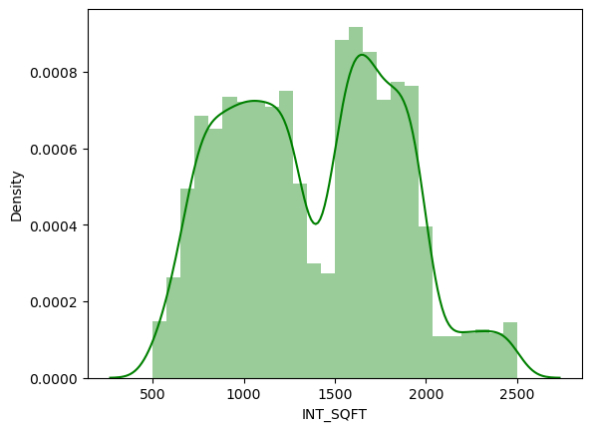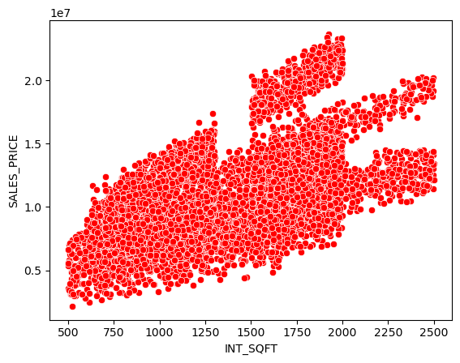

**It is case of a linear relationship, therefore No transformation required**

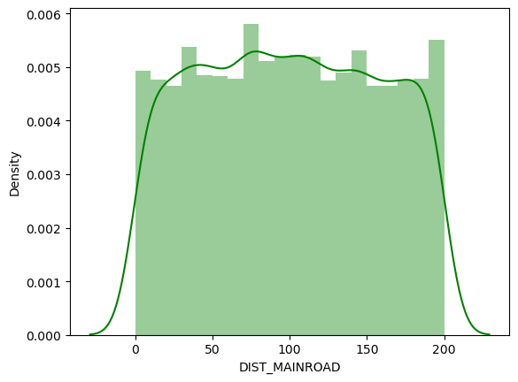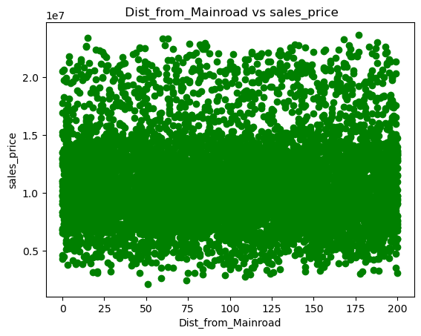

**We can ignore this feature as it doesn't affect our target because there is no linear relationship.**

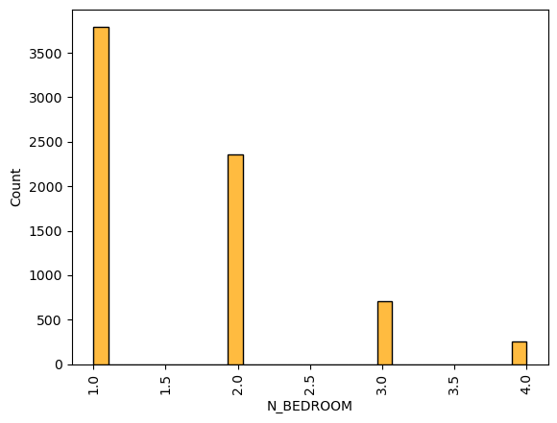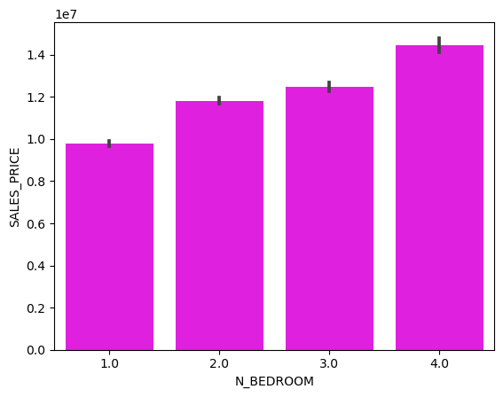

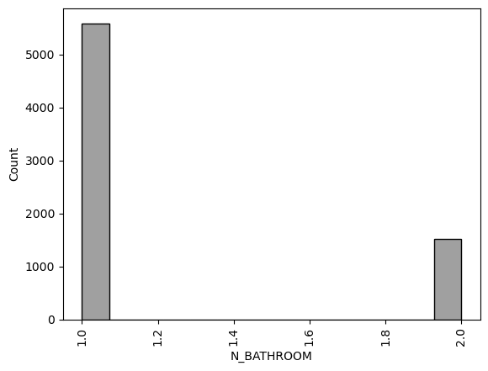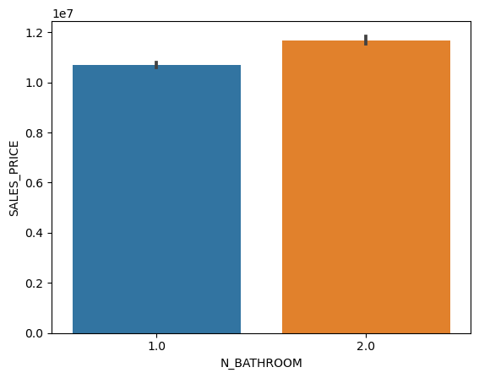**No transformation required because there is linear relationship present.**

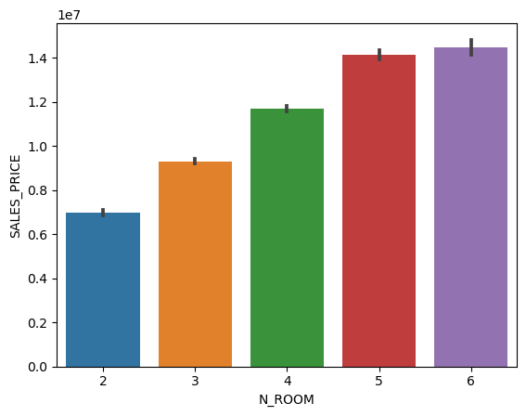**No transformation required because there is linear relationship present**

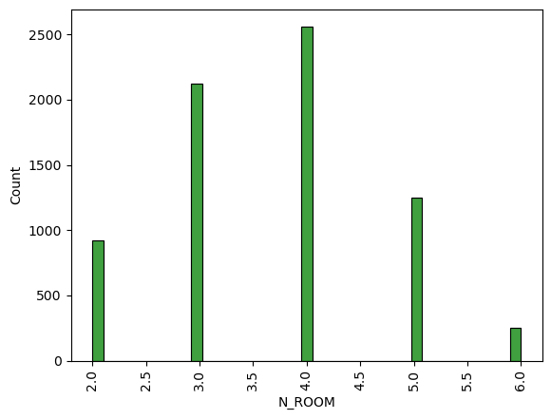

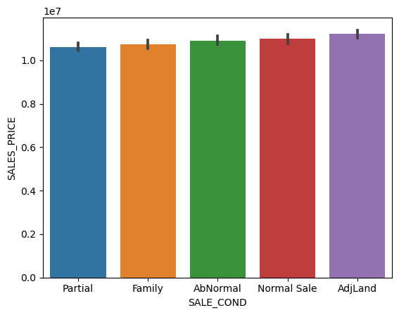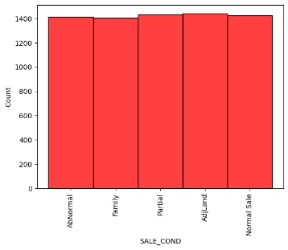**No transformation required because there is linear relationship present.**

**Label Encoding is required because there is linear relationship present.**

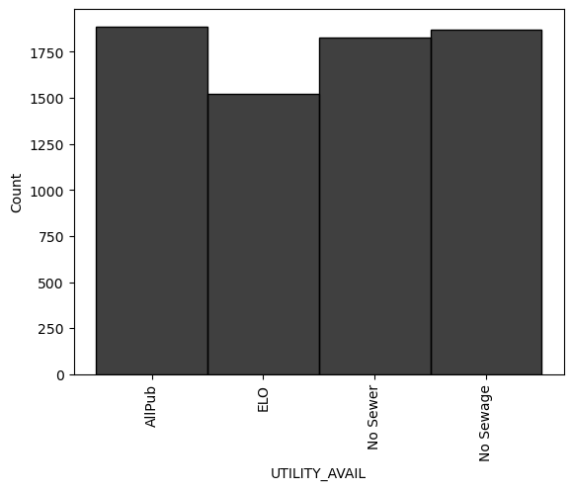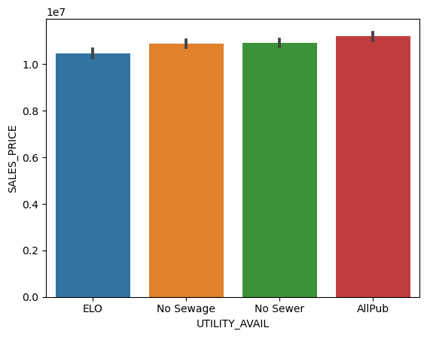

**SALES_PRICE 1.0**

**Label Encoding is required because there is linear relationship present.**

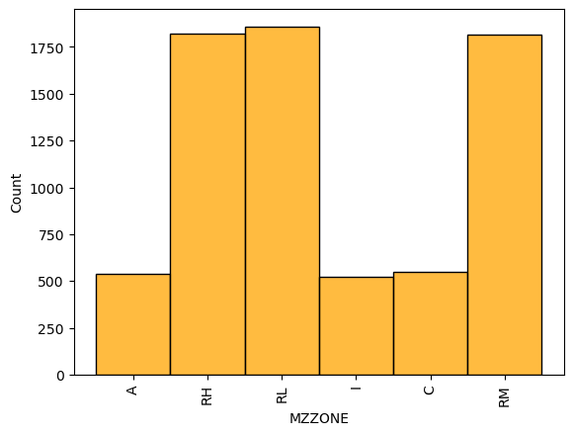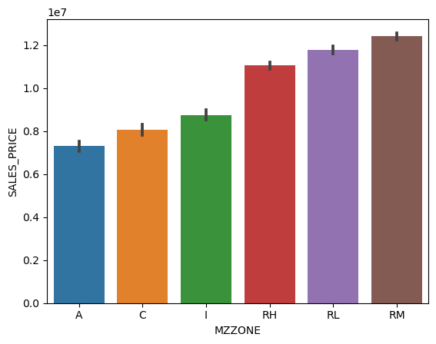

**We will go with Label Encoding and it has a linear relationship**

**SNS Heat Map**

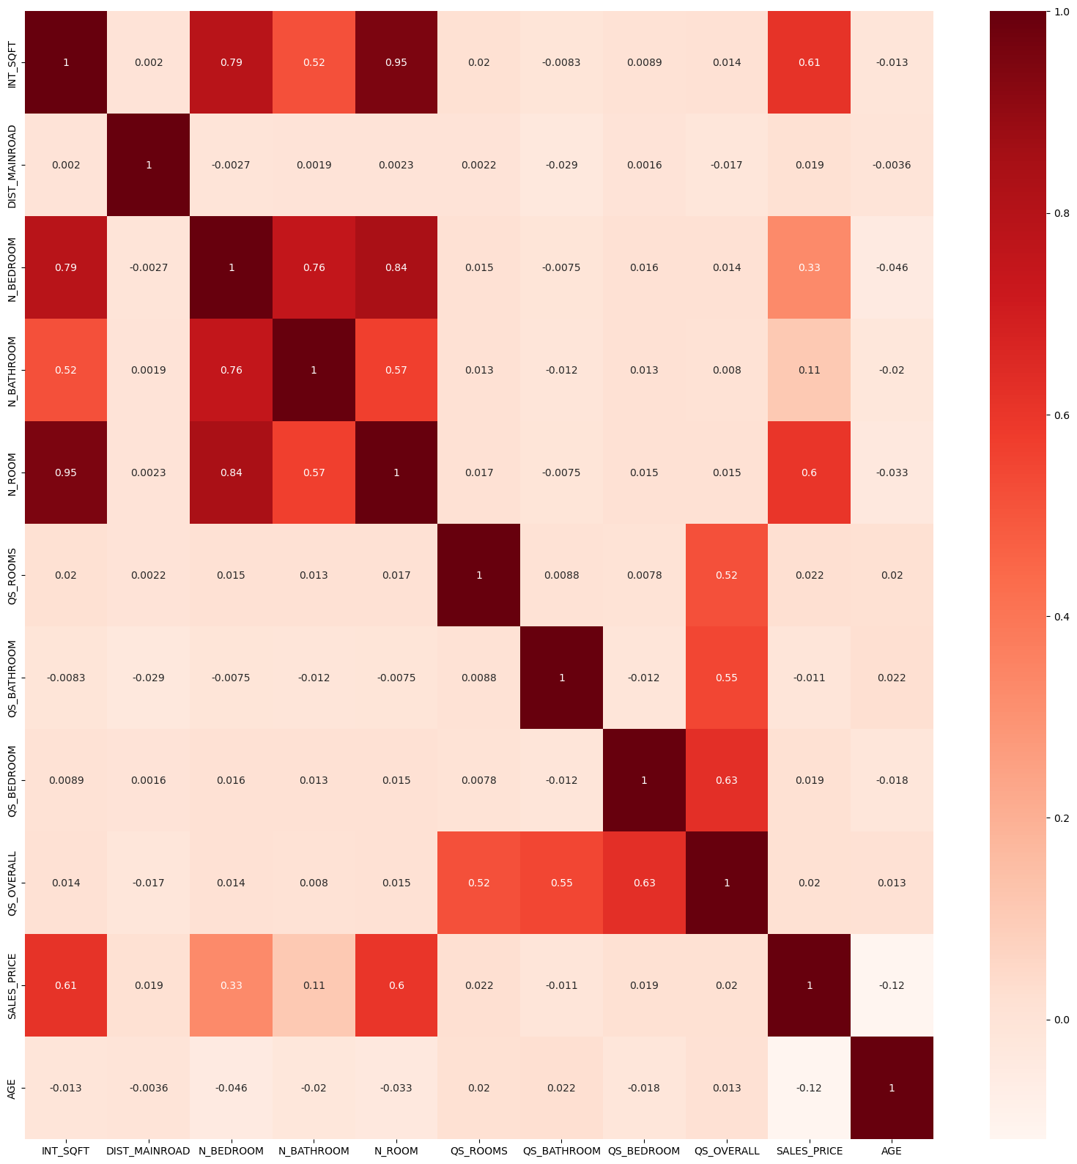

Evaluation metrics of all models constructed:

**The r2 score of Linear Regression model is : 0.9239694289388293**

**The cross validation score of an KNN regresssor model: 0.9479184353354475**

**The cross validation score of Decison tree regressor model: 0.9744198212278894**

**The cross validation score of an XG_Boost regessor model is :0.9973228506593521**

Answers to Buyers and suggestions to Real Estate Agents

**Answers to Buyers:**

**The price of the property changes due to various factors. Top factors are:**

**1)The price changes also on Availability of Parking.**

**2)Based on the location of the property.**

**3)Based on whether the property is Commercial,others or House**

**4)Finally based on the Zone which the property belongs to**

**Suggestions to Real estate agents:**

**The profit can be increased by considering the following factors:**

**1)Constructing buildings in T Nagar, Anna Nagar and KK Nagar can result in more profit.**

**2)It is highly recommended to construct buildings with Parking Facility.**

**3)The Street of property should be Paved and it should have All Public facilites nearby.**

**4)It is recommended to construct a commercial bulding rather than residential or others.**